Colour Examination of the EBGE Website
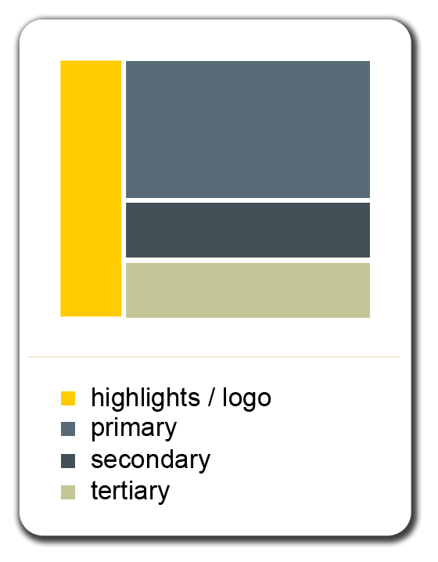
Figure 1: EBGE Colour Scheme

STFU has examined a few website templates and their associated colour schemes and found one that matches the feel and character of the EBGE website.

We chose a couple of shades of blue to make up the majority of the site’s colour. The colour blue is proven to be extremely effective in promoting and advertising technological products (video gaming has its bases in modern technology) and provides a sleek, polished feel. Blue is also a “male colour;” most males can associate with and feel comfortable around it. Masculine as blue is, there is no indication in our research that it alienates females. STFU feels that the video game genres we have chosen, especially first-person shooters, are also very masculine elements, and that the blue will only enhance that masculine connection. More specifically, the shades of blue we have chosen are on the darker side; dark blues represent power and integrity, a feeling that we wish site visitors to experience.
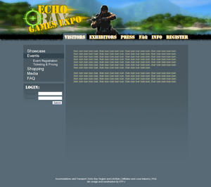
Figure 1: Colours of the site come together
Two additional colours that make up the design are a light beige colour and a bright yellow/gold colour. The beige will be used primarily for the font colour and for glows around titles. The bright yellow/gold colour is to be used in the logo and highlights (such as borders around images). The logo will combine the yellow with other bright, hot colours to ignite the sense of action and intense energy. The contrast between the blues will also draw the eye to the logo to intensify these feelings.

http://www.selling-it.com/Useability/Color/Use_Color_Meanings.htm

